Name: ___________________

NetID: ___________________

Discussion Section (*make sure to include!*): _________

Linguistics 1010

Make-Up Assignment

Week 14

**Animal Communication**

1. Describe two ways that human languages and animal communication systems are similar, and two ways that they are different?

1. Describe the three parts of the bee waggle dance, and what message each part of the dance communications.
2. Bees demonstrate that even insects can have complex innate knowledge. Describe two pieces of complex knowledge that bees appear to have innately.
3. Watch the following short movie about bees and answer the following questions:

<https://www.youtube.com/watch?v=16SMpTXpuuY>

a. What is the communication system used in the movie?

b. Why did the bees in the movie use this communication system instead of the “waggle” dance?

c. Suppose humans were fluent in the bee “waggle” dance. Could it then be used in the movie?

1. Describe one example of a critical period effect that occurs in animals.
2. Nim Chimpsky the chimpanzee was taught signs based on American Sign Language in an experiment. He learned around 125 signs, but never learned human syntax. Describe two properties of his utterances that show that he did not learn human syntax.
3. Kanzi the bonobo has shown the ability to distinguish “The dog bit the snake” and “The snake bit the dog”. Explain how this difference differs from human syntax using the ideas of linear order and hierarchical structure.

**Exam 3 Review**

1. What is *confirmation* in science?
2. What is the *problem of confirmation* in science?
3. What is *falsification* in science?
4. Why did some philosophers argue that falsification is superior to confirmation?
5. Given the “scientific” definition of *language* in the cognitive sciences, is there a distinction between a *language* and a *dialect*? Explain.
6. List two examples of scientific facts about African American English that show that AAE is a full human language (and therefore can be used to fight language prejudice and discrimination against its speakers).
7. Name the four lobes of the brain:

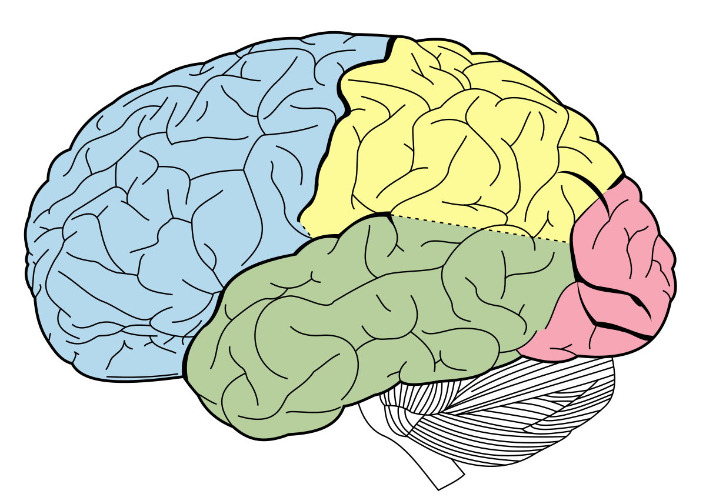

Blue =

Green =

Yellow =

Red =

1. Provide two pieces of evidence that sign languages are full human languages.
2. Please summarize the scientific argument (based on language performance) that should children be exposed to a sign language as early as possible in their lives?